Order Date: / / Contact Information
Agency:
Contact Name: | 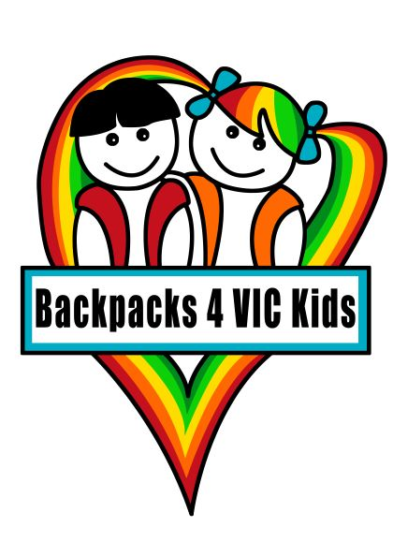  Phone:
Email:
Delivery address:

ME Jnr Pack  Size | Unisex (number required) | Boy (number required) | Girl (number required) | Comments  (any additional comments you would like to make)
0000
000
00
0
1 | N/A
2 | N/A
3 | N/A

ME Pack  Clothing Size | Boys  (number required) | Girls  (number required) | Comments  (Any additional comments you may wish to add)
4
5
6
7
8
10
12 (or Adult size 8/XS)
14 (or Adult size 10/S)
16 (or Adult size 12/M)
18 (or Adult size 14/L)

Note: My Essentials Junior Packs contain at least 5 disposable nappies

On completion, please email this order form to adminteam@b4vk.org.au or telephone 0412 205 943

